How to Check Your Balance and Account Transactions

Balance on Your Account

- Log onto My.FresnoState.edu.
- Click on Student Self Service Student Center My Finances Account Inquiry
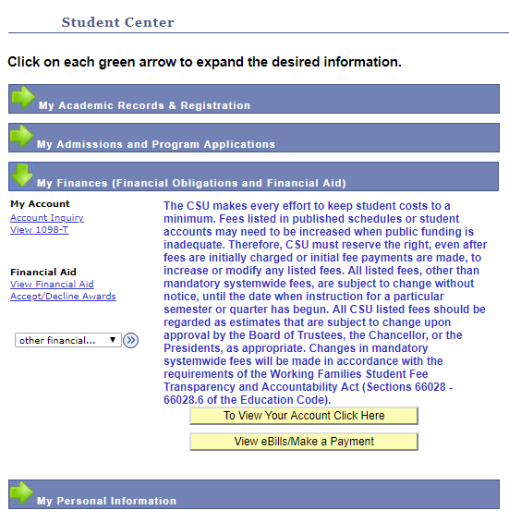
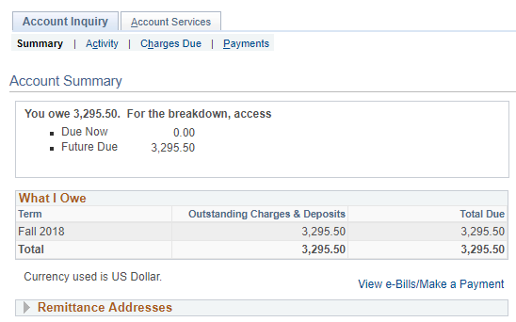

- On your Account Summary, you can view your current balance. If there is no outstanding balance shown, you do not owe anything! You can contact the Accounting Services Department at (559) 278-2876 if you believe amounts are incorrect.

Viewing Account Transactions
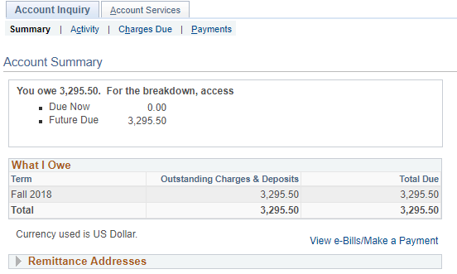
Click Activity to view your Account Transactions
On this screen, you can view all of your fees and payments, paid to tuition and fees by either you and/or the Financial Aid you received. You can also view refunds.
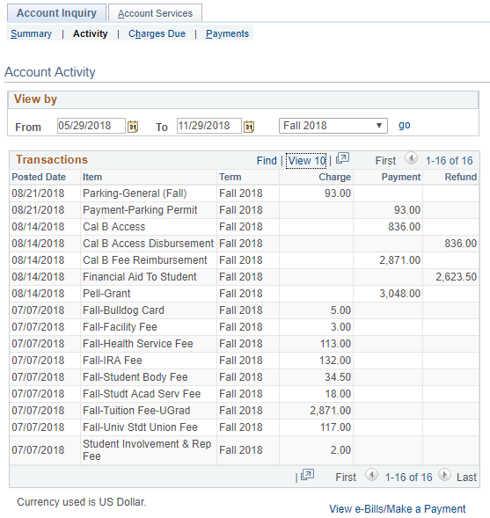

If you are wondering if your Financial Aid has been refunded, you can also view it here, under the Refund column.

Please feel free to visit us in the North Lobby of the Joyal Administration building, or give us a call at (559) 278-2182!

