
Test Anxiety
Of course everyone has some anxiety about tests. It has been estimated that as many as 20% of college students may suffer from nervousness that is so severe it affects their grades and their overall quality of life.

- Use lists & headings to your advantage.
- Read your text book before class in order to pick out the main points.
- Pay special attention to handouts and definitions of terms.
- Take thorough notes to refer back to
- Outline note-taking style is also helpful to keep notes organized.

- Have pencils, scantrons, blue books, calculator, and gum/stress ball ready before exam.
- Go into the exam thinking positive thoughts such as, “I’ve worked hard in this class. This exam is a chance for me to show everything I’ve learned”.

- While reading a question, look for cue words or phrases. Focus on one answer at a time so you can eliminate those that do not fit.
- If you start to panic use your stress ball, or chew some gum. Take a few deep breathes and remind yourself of those positive thoughts.
-

- Go back and review the questions you missed. Talk to your professors or peers to help clarify any misunderstanding.
- Use your test information and experience to help you prepare for future exams.

Test Anxiety Action Plan
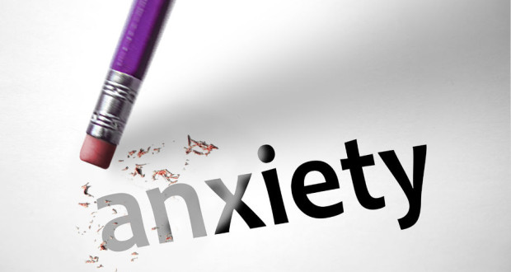
Circle the number that best describes how much anxiety you have been experiencing:

☐0 ☐1 ☐2 ☐3 ☐4 ☐5 ☐6 ☐7 ☐8 ☐9 ☐10
None High

Now that you learned about test anxiety and steps for you to manage your anxiety, it’s time for you to come up with your own plan on what you will do to help erase your test anxiety.

What (Explain what occurs when you are experiencing your anxiety):
Click here to enter text.
How (What strategies can you use to handle your anxiety):
Click here to enter text.

Frequency: Click here to enter text. Times a Click here to enter text.

How confident am I that I will do this plan:
☐0 ☐1 ☐2 ☐3 ☐4 ☐ 5 ☐6 ☐ 7 ☐8 ☐9 ☐10
Unlikely Likely

