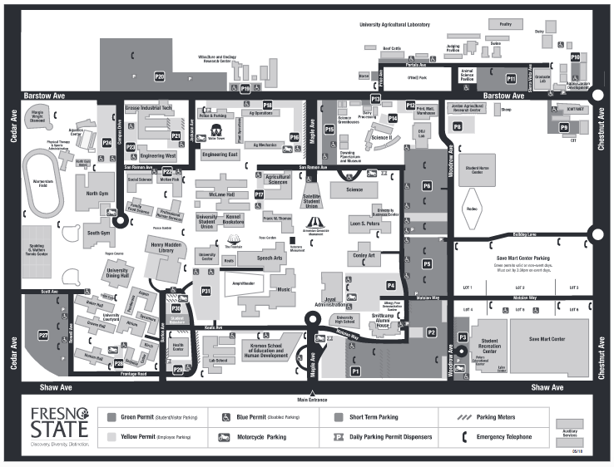
Project Rebound Office: Social Science Building, Room 106 (Red Circle)

Parking with Purchased Day Pass: P21, P23, P24

Coin operated Parking: P21 (Blue Arrow)

