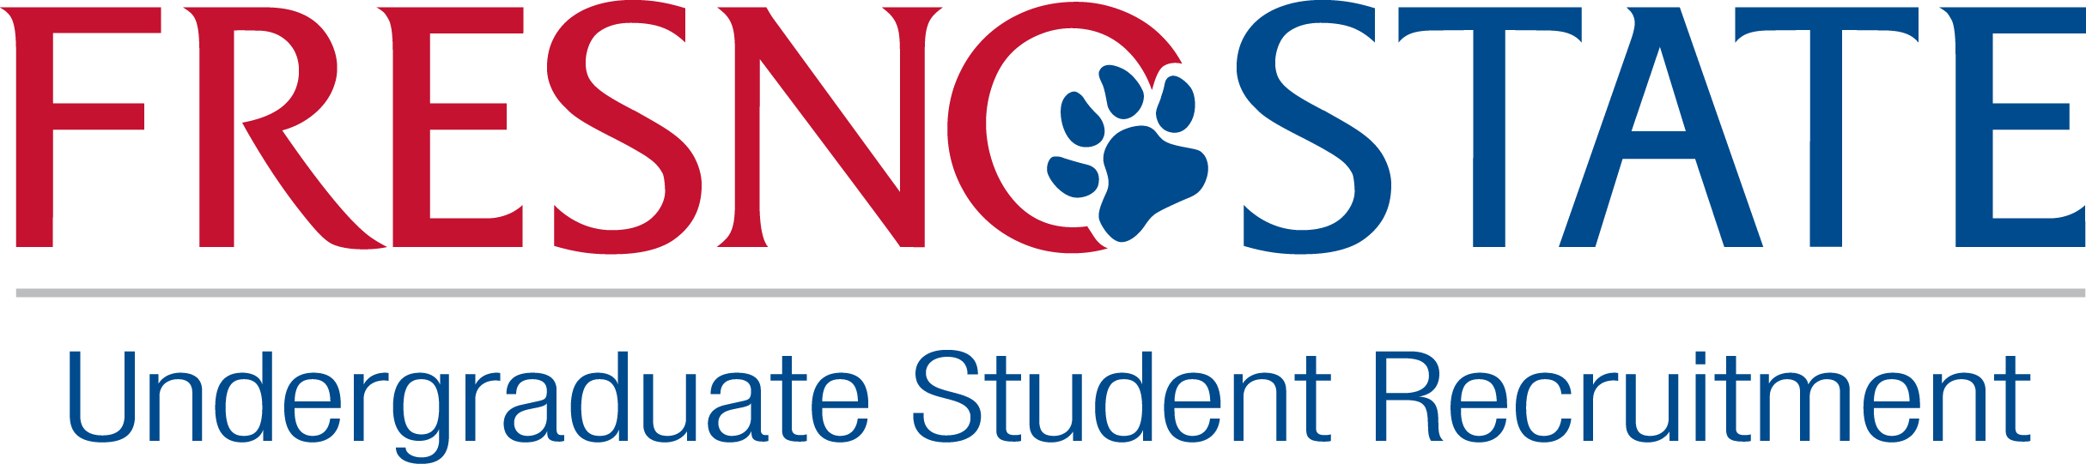

Changing Our Community One Student at a Time
Being a high school ambassador is more than just visiting schools. You’re the face of Fresno State to prospective students, their families, school personnel and the community. The high school ambassador plays a major role in helping students navigating the admission process and contributes to the university meeting its enrollment target. If you’re proud about sharing your Fresno State experience, are excited about working with a diverse population and have a passion for changing lives, you may be exactly who we are looking for!

We Are Looking for Students Who:
- Have good customer relations and enjoy working with people
- Are articulate, organized, professional and responsible
- Share a strong enthusiasm for Fresno State
- Are positive and outgoing
- Are willing and capable to learn processes with the goal of enrolling students to the university
- Work well with individuals and groups in a public environment
- Know our campus, its events and activities well
- Can address all questions optimistically
- Have timely attendance
- Reflect the diversity of our student population
- Preferably available to work a minimum of 3-4 hours or more blocks of time in a day
- Bilingual a plus

As a High School Ambassador, You:
- Are assigned to one or more local high school(s)
- Serve as a role model fostering a college going culture for prospective students
- Share the Fresno State opportunity to prospective students/parents/school personnel
- Inform students about Fresno State admission requirements to ensure they are on track to meet eligibility
- Guide and assist students with processes from application to enrollment and inform them of various opportunities such as special programs, financial aid and others
- Document student contacts and are responsible for following up with prospects
- Participate and assist with occasional evening and weekend programs as designated by supervisor or director
- Conduct small and large group presentations
- Represent Fresno State at various community or high school sponsored events
- Participate in all mandatory high school ambassador trainings/meetings
- Adhere to university/office/high school policies and procedures
- Perform other duties related to this position as assigned by the program supervisor or director

Minimum Qualifications:
- Enrolled at Fresno State
- Cumulative GPA of 2.5
- Valid California Drivers License, good driving record and auto insurance (have your own vehicle is preferred)
- Ability to drive under various weather conditions to school sites
- Work a maximum of 20 hours per week Spring and Fall semester, some Saturdays and holidays
- Possess strong communication skills (written and verbal)
- Ability to work independently
- Ability to interact with multi-ethnic and multi-cultural population in a professional and respectful manner

Starting Pay:
- Starting pay for the high school ambassador position is $10.00 per hour

Apply Now
Applications need to be submitted for first review by May 20, 2016 we will continue to review application after this date until position is filled.
3 ways to submit completed application (1) Online at bulldoglink on the Career Development Center website (2) Turn it in person to UC100, attention Christine (3) by email to crotzinger@csufresno.edu.
All applications received must have the following to be considered complete:
- Application
- A cover letter
- A copy of your resume
- A copy of your unofficial transcripts
- A copy of your DMV driving record
- Proof of automobile insurance
***Interviews will be held during the months of June
Selected high school ambassadors will be required to attend a mandatory week long training the early part of August.

Application: High School Ambassador for Undergraduate Student Recruitment
Please print or type. All application areas must be completed. Please attach a cover letter, resume, your unofficial transcript showing proof of enrollment and GPA with this application, DMV record and proof of insurance. Incomplete application will not be considered. Resumes will not substitute for a completed application. (Ways to submit completed application (1.) online at bulldoglink on the Career Development Center website (2). In person to UC100 attention Christine (3) by email to crotzinger@csufresno.edu. Applications need to be submitted for first review by May 20, 2016 we will continue to review application after this date until position is filled.

Name (First/Last)_______________________________________________________

Address________________________________________________________________

City __________________________ State _____________ Zip ___________________

Contact Phone Number ________________________________

Contact e-mail Address: __________________________________________________

CSUF ID# ___________________ Current Class Level _____________________

Expected Graduation Semester & Year ______________ Overall GPA___________

Have you requested work-study? ___________________

Do you speak another language? If yes which language? ________________________

Fresno State Tour Guide Application Con’t
Please answer the following questions. If you need more space please use a separate piece of paper.
- Please tell us about what student organizations are you currently involved in?

- Why did you choose to attend Fresno State University?

3. Why would you like to become a high school ambassador?

4. Describe your public speaking and presentation experience.

Work History: Please list prior work experience and/or volunteer experience (last job first): If you need more space please attach a separate sheet.
From | To | Job Title & Description | Address & Telephone | Employer/Supervisor
From | To | Job Title & Description | Address & Telephone | Employer/Supervisor
From | To | Job Title & Description | Address & Telephone | Employer/Supervisor

Fresno State Tour Guide Application Con’t
List three (3) references that may be contacted to comment on your abilities:
Name, Occupation, Phone #
1. _____________________________________________________________________
2. _____________________________________________________________________
3. _____________________________________________________________________

Please check the hours you are available to work during the fall semester:
Time | Monday | Tuesday | Wednesday | Thursday | Friday | Saturday
8:00am-9am
9:00am-10am
10:00am-11am
12:00pm-1pm
2:00pm-3pm
If you already registered for classes, please attach a copy of your class schedule.

I confirm that the information provided above is true to the best of my knowledge, and I understand that information found to be false can jeopardize my chance of being hired for this position.

________________________________ ______________________________
Signature Date

Application Checklist:
- Application
- Cover Letter
- Resume
- Unofficial Transcript
- DMV Driving Record
- Proof of Automobile Insurance

