TRIO Student Support Services Program (SSSP) TRIO Student Support Services Veterans (SSSV)
Newsletter
FALL 2017

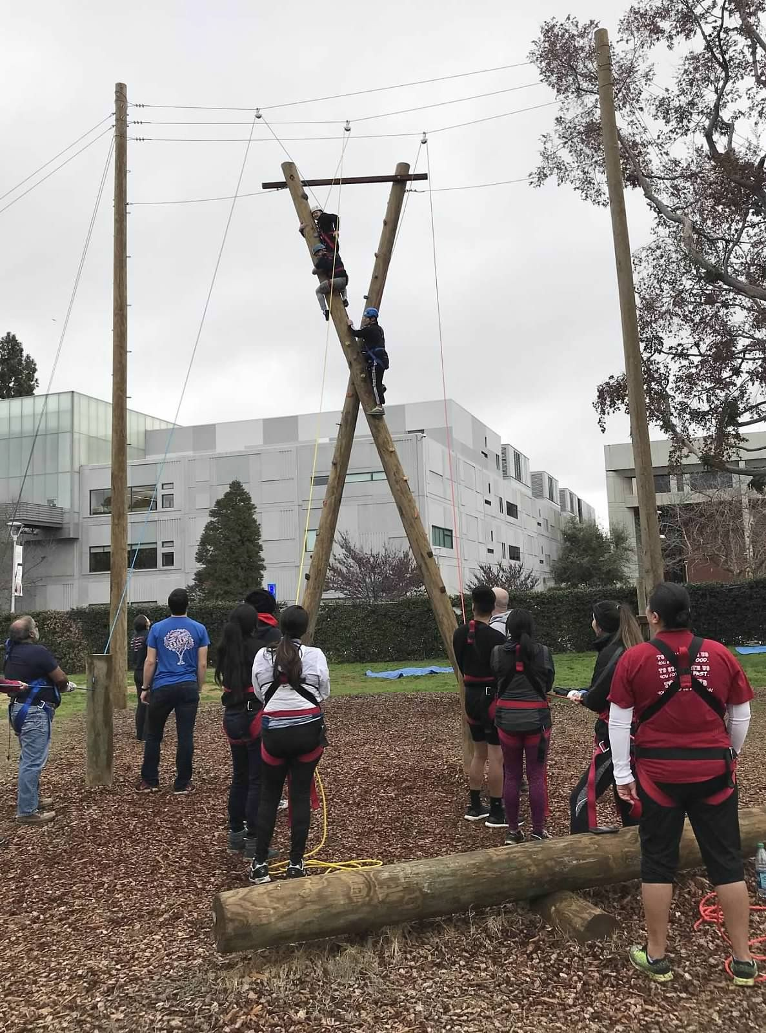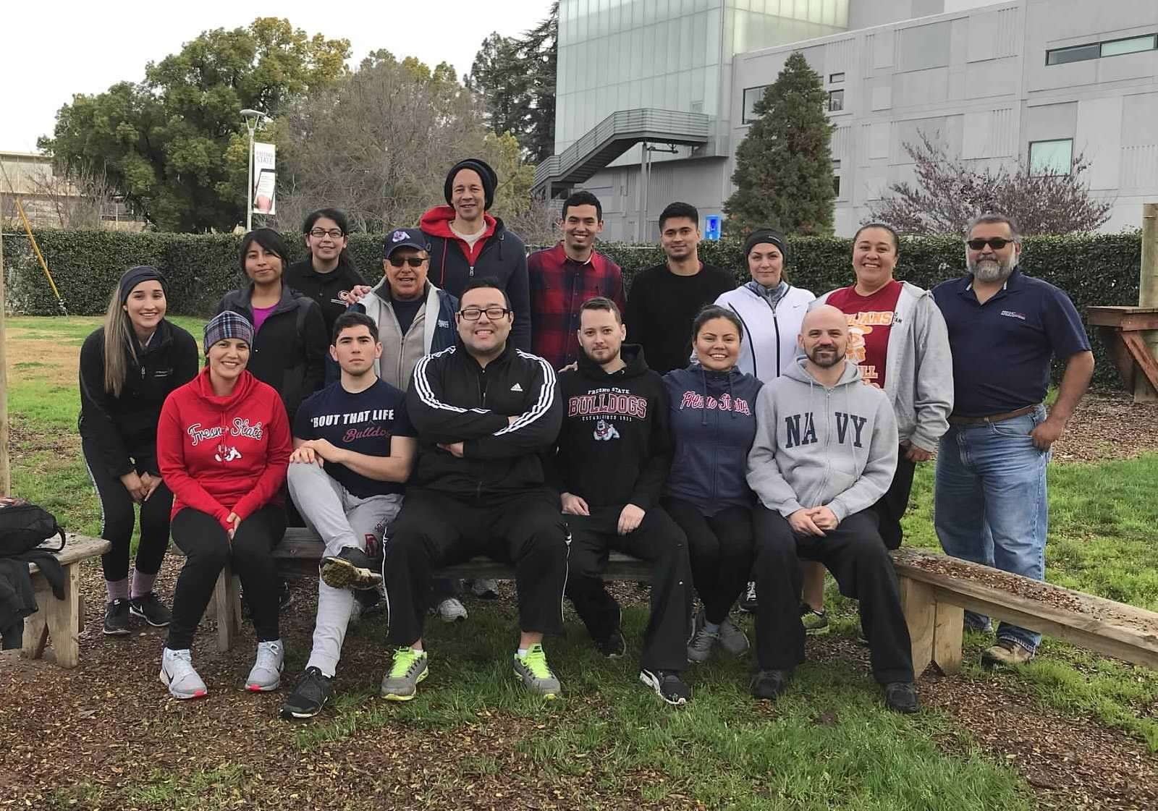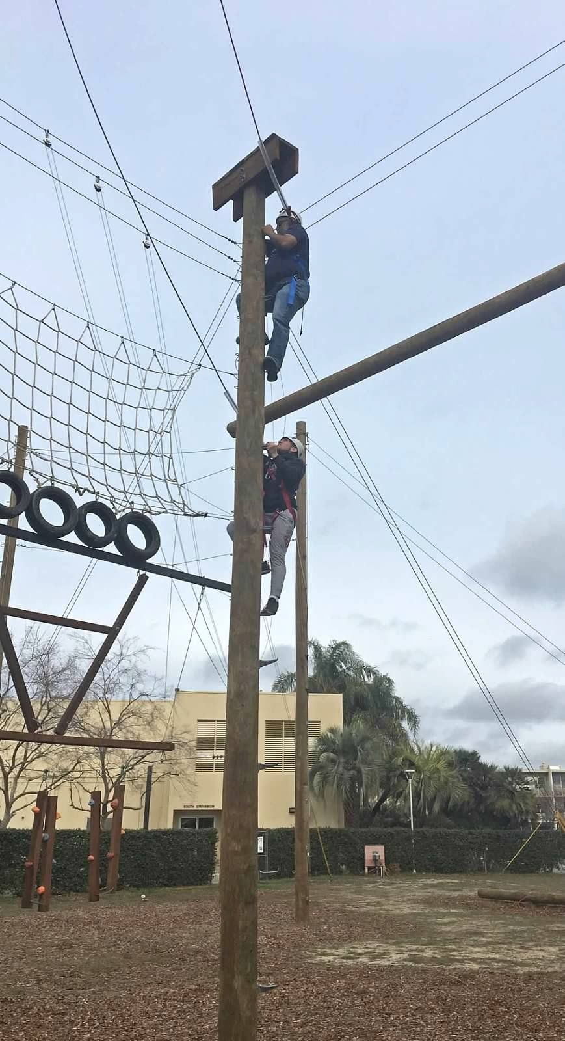
Published by: Celeste Tafolla, Kinesiology Major and Gail Harris (USA), Liberal Arts Major
Edited by: Jamile Bucio, Psychology

Photos by: Joe Guerra

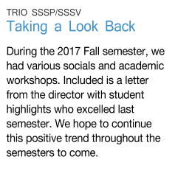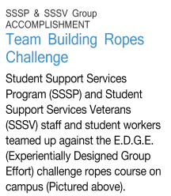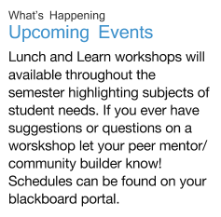

Director’s Letter

Welcome Back Everyone,
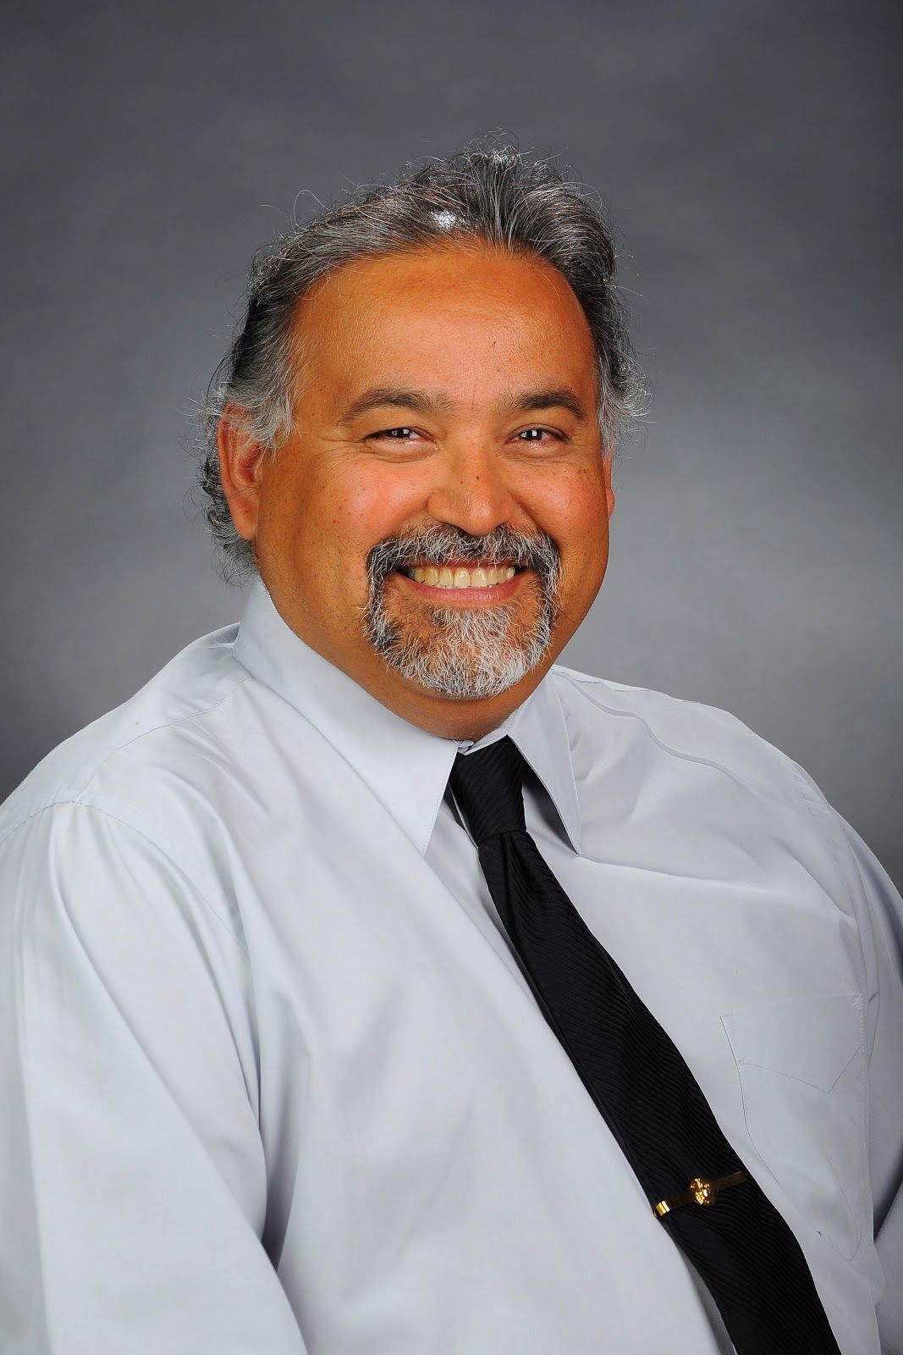I want to share some TRIO Student Support Services Program (SSSP) and TRIO Student Support Services Veterans (SSSV) highlights from the fall 2017 semester and 2017 winter intersession. Because there are so many, I will present in bullet point format:
- SSSP has held a 93% persistence rate
- SSSP has held a 92% good standing rate
- SSSV has held a 90% persistence rate
- SSSV has held a 90% good standing rate
- SSSP and SSSV held its first field trip to Kings Canyon National Park
- Richard Reyes, SSSV Veterans University Community Builder (VUCB), started his national internship with the Department of Interior, Bureau of Reclamation
- SSSP Peer Mentors and SSSV VUCBs both carried out a number of social and networking opportunities for both SSSP and SSSV students
- SSSV VUCBs, Anna Rivera (USA) and Zamies Hernandez (USN), combined artistic abilities to create the football helmet logo for the Veterans Tribute football game
- SSSV VCUB, Luisana Martinez (USA), arranged a first time session with Children’s Services Network, which supported services for both SSSP and SSSV parents of child care needs
- SSSP and SSSV community partners; Veterans Affairs Medical Center, Fresno County Veterans Services, Office, Central Valley Veterans, Fresno County VA Vocational Rehabilitation and Employment, and others provided on-campus sessions
- Henry Madden library Veterans Exhibit during the month of November
- Veterans Appreciation Luncheon for faculty, staff, and students
- Comcast developed a commercial with SSSV in which Josh Delano and his children were interviewed to demonstrate how Comcast’s Internet Essentials could benefit Veteran students and their families-Link: https://comcast.box.com/s/1uwhkb1iupmkeb635syu1rtvjkxlh00u
- 50 laptops were donated from Comcast Joint Diversity Council to SSSP and SSSV
- SSSP and SSSV Team completed the high and low EDGE course
All of these successful events could not have happened without Crystal Benavidez (USN), Joe Guerra (USAF), and Russell Gross (USMC), who lead student leader teams for the retention and success of all SSSP and SSSV students. In the future, you will learn how our new staff member, Kelly Maravilla, has contributed and will continue to contribute to the success of all TRIO projects.
I wish everyone a successful spring semester. Eluterio L. Escamilla (USMC) – Director
TRIO SSSP and SSSV

Ernie Perez Jr.
Student Accomplishments
Stephanie Rivas (USA) Organizes Women Veteran Connection Luncheon

My name is Ernie Perez Jr. and I am a
first-generation student from Lanare, CA. Right after high school in 2012, I went to Fresno State where I received my bachelor's degree
in Psychology. I decided to continue my education through the School Psychology graduate program here at Fresno State. I started off with TRIO Student Support Services in 2012, but I was only a student like all of you. By the end of my sophomore year, I became a peer mentor with SSSP and later became a community builder. I am currently an academic facilitator as I continue my journey with TRIO. As an individual coming from a small community where opportunity is very minimal, I want to tell you to keep your motivation going throughout your studies and have a positive mind. All things are possible!

-Ernie Perez Jr.
Last October, SSSV hosted a Women Veteran Connection Luncheon led by Veteran student, Stephanie Rivas. Stephanie served four years in the Army as a medic. Her medical pursuit continues here at Fresno State as she works towards a bachelor's degree of Biology with the goal of becoming a Physician's Assistant. The luncheon was organized to present an opportunity for Fresno State Women Veteran students, staff, and faculty to gather, socialize, and connect with one another. At the catered event, icebreakers and games were played with prizes in store for all who came. The Women Veteran attendees differed in age, military rank, job title, and branch of service, but they all found it easy to spark conversations about past experiences on duty, motherhood, and college life. The luncheon was a great success. SSSV plans to continue growing the Women Veteran Connection through future social events.

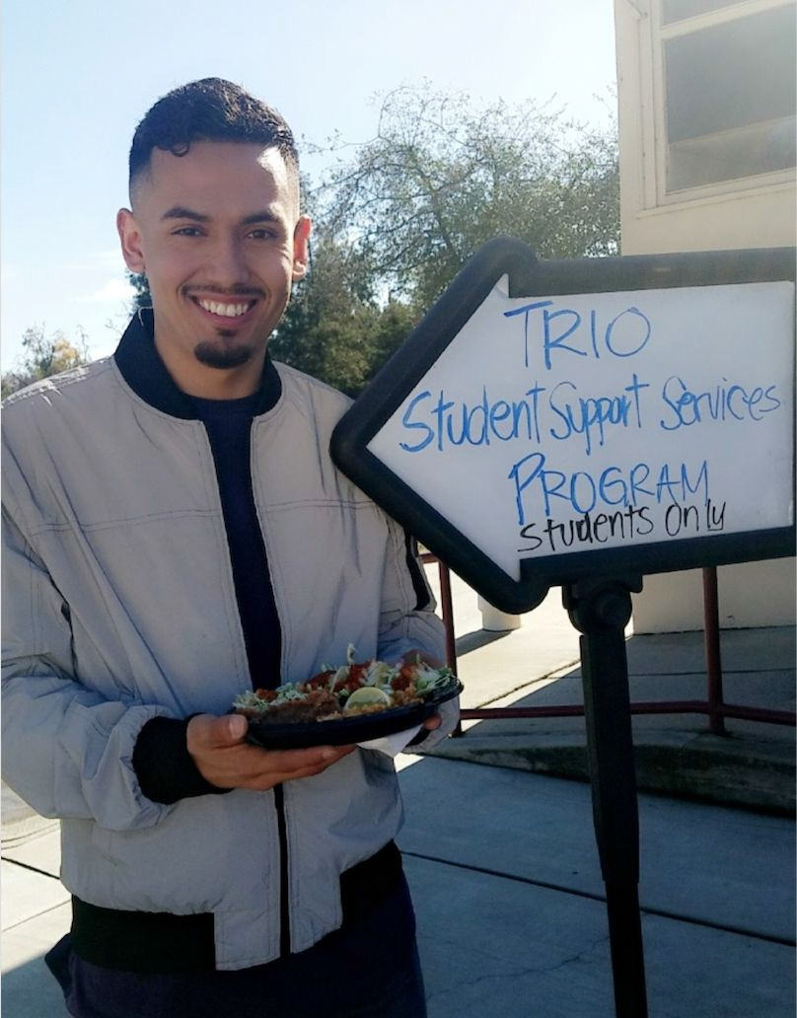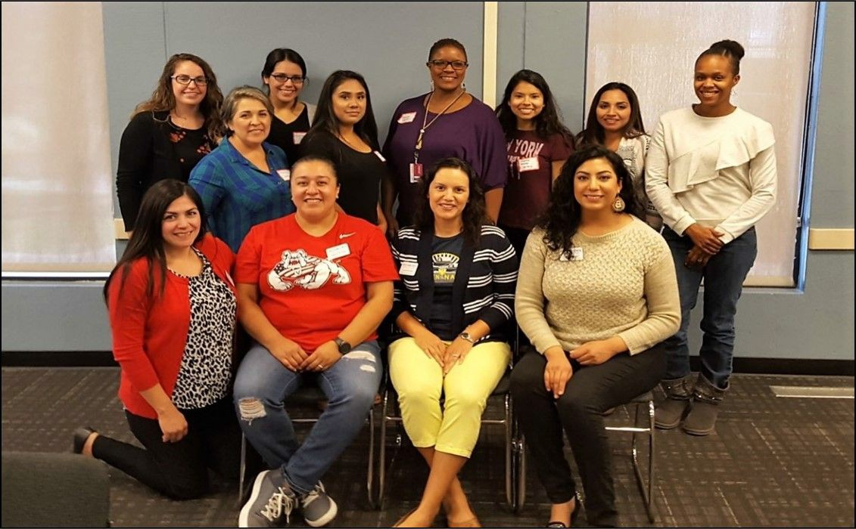

Feel free to say “hi” when you see me in the computer lab!

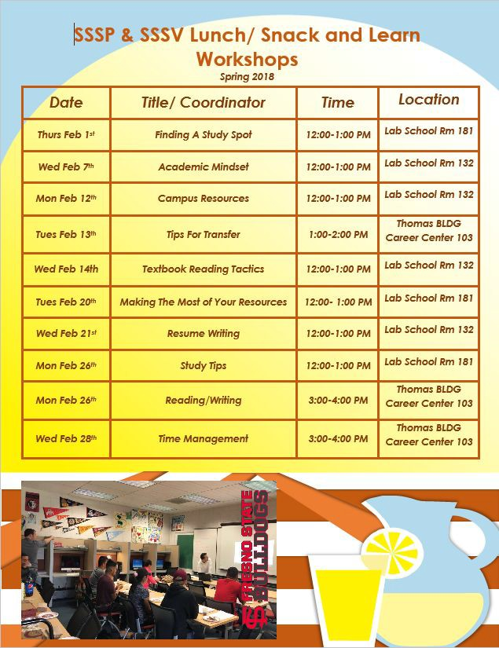

Fall GPAs

Congratulations On a Job Well Done
The TRIO Student Support Services Program excelled academically this past fall semester. We serve over 200, 29 of which obtained a perfect 4.00 GPA and 141 obtained higher than a 2.75. Way to goThe Student Support Services Veterans has approximately 135 students. Of these, 19 Veterans earned a 4.00 and 80 earned a 2.75 of better GPA.
“Keep your dreams alive. Understand to achieve anything requires faith and belief in yourself, vision, and dedication. Remember all things are possible for those who believe.” ~ Gail Devers

Tutoring Schedule for Spring 2018 in Lab School Room 10

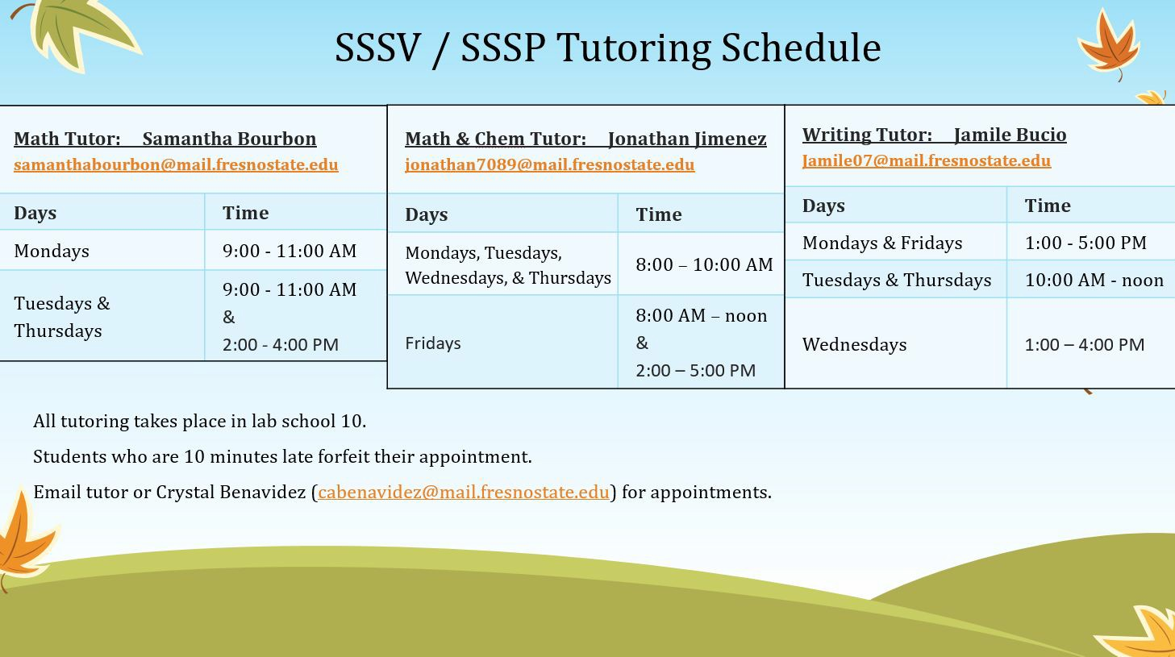

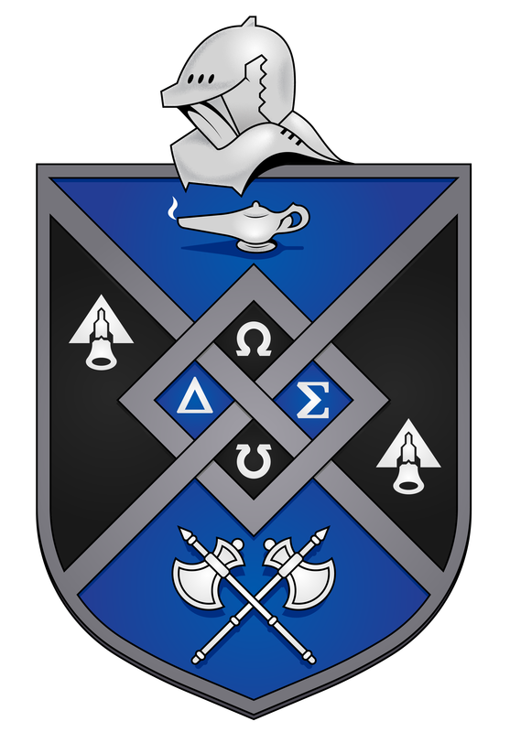 Omega Delta Sigma
Fresno State’s Co-ed Veterans’ Fraternity is now looking for new
members! This unique fraternity will provide any Veteran, transitioning from military to school life, the opportunities to succeed in life. With the guidance of well-rounded mentors, make the network connections you need in your career field to give you a boost into the civilian life. Bring your family to any of their
many Veterans’ socials and connect with like-minded individuals. Join the involvement as this brother/sister-hood gives back to the Veterans of the community. Inquire with Bryant Coleman at bColeman273@mail.fresnostste.edu.

About Us
We are located in Lab School Room 9 and 10 Monday - Friday 8:00 AM- 5:00 PM
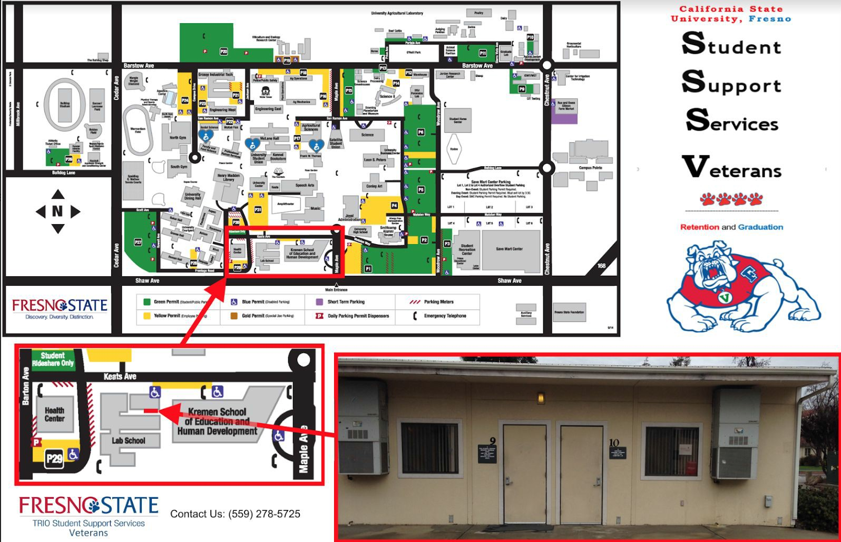Closed for Lunch 12:00 PM - 1:00 PM

TRIO SSSP/SSSV Benefits
- Access to a Counselor
- Computer Lab
- Free Printing
- Academic Workshops
- Social Events
- Grant
- Textbook Library
- Tutors
- Reading/Writing Specialist
- Peer Mentors
- Community Builders

Follow and Like Us


@fresnostatetriosssp | @sssptrio | @FresnoStateTRIOSSSP
@fresnostateSSSV | @fsutriosssv | @fresnostatetriosssv

