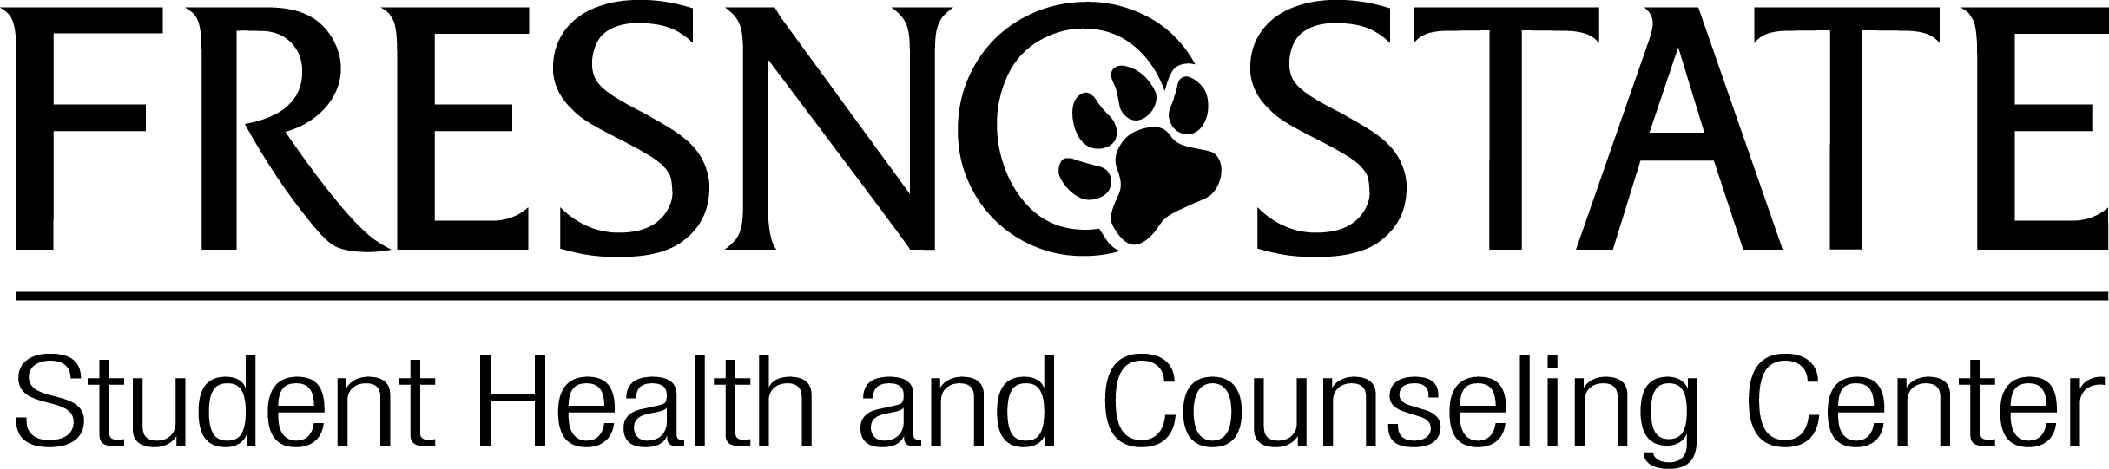
Violence Prevention and Victim Assistance (VPSA) Student Assistant
Deadline for submission: November 20, 2015
Submit application to: Kathy Yarmo, kyarmo@csufresno.edu
Applicant Information:
Name: |  | Phone:
E-Mail Address:
Major(s): | Minor(s):
Year in School: | Expected Graduation Date:
Student ID #: | Spring 2015 GPA:

1. Why are you interested in this position and what do you hope to gain from it?

2. What personal resources and skills will you bring to our program that relate to the position(s) for which you are applying?

3. Please list any jobs, volunteer work, participation in student organizations, and/or course experience you have related to the position. You can supplement this answer by attaching a resume.

4. Please describe any public speaking experience or training you have received.

5. Please describe your marketing/media/social media skills and experience.

6. Please list the time commitments you have this semester (e.g. academic responsibilities, student organization involvement, other work and/or athletic responsibilities).

7. Please list two references (no friends or roommates please):
Name Phone Relationship
(1)__________________________________________________________________________________
(2)__________________________________________________________________________________

