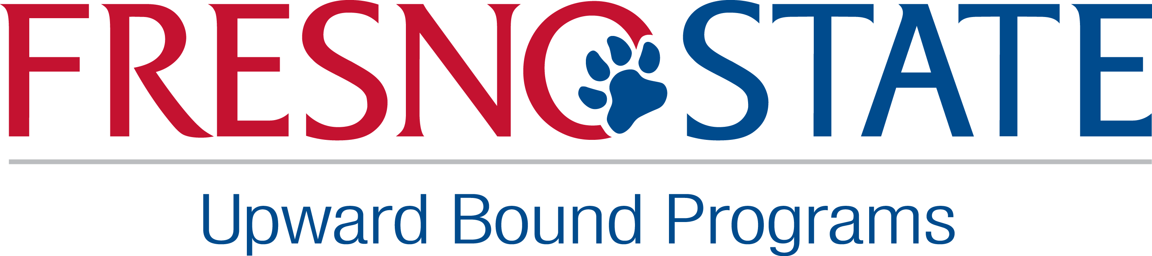
Job Announcement
Program Assistant

Program | PROGRAM ASSISTANT – Part-time (approximately 12-20 hours per week), position with the Upward Bound (UB) Program through the California State University, Fresno Foundation.
Summary: | Upward Bound (UB) provides fundamental support and opportunities to participants in their preparation from college entrance, so they can succeed in their precollege performance and ultimately in their higher education pursuits. Upward Bound serves low-income and or first generation high schools. The goal of Upward Bound is to increase the rate at which participant complete secondary education and enroll in and graduate from institutions of postsecondary education.
Essential Job  Functions: | Under the supervision of the Office Manager and the Program Director, the Program Assistant will be responsible for the following. Typical duties include, but are not limited to the following:  - Monitor and track the academic progress of UB participants through high school and college years.  - Assist in the coordination of the academic year and preparation of summer component.  - Input data onto database.  - Monitor student’s attendance and program participation.  - Maintain master lists, perform clerical duties, and attend weekly staff meetings.  - Develop leadership, motivational and educational student related activities.  - Attend mandatory staff meetings on Friday’s.  - Be available and willing to work evenings and weekends when needed.  - Carry out other assignments as delegated by permanent staff.
Position Requirements: | To perform this job successfully, an individual must be able to perform each essential duty satisfactorily. The requirements listed below are representative of the knowledge, skill, and/or ability required. Reasonable accommodations may be made to enable individuals with disabilities to perform the essential functions.  - Must have at least a cumulative 3.0 GPA in all college work  - Must be a currently enrolled college student with at least two (2) years of college experience  - Must have knowledge and provide assistance to participants with college admission, financial aid, scholarships, career development and high school graduation requirements  - Computer literate in Microsoft Office (Word, Excel, PowerPoint), email, database, and other software  - Must have the ability to make presentations and prepare written reports  - Possess excellent oral and written communication in the English language  - Bilingual skills desired (Spanish or Hmong)  - Good customer service, leadership and interpersonal skills  - Must demonstrate sensitivity towards students from diverse cultural and socioeconomic backgrounds  - Must pass background check by State Department of Justice
Salary: | $12-13.00 per hour, depending on experience.
Deadline: | August 31st, 2017 at 4:30pm
To Apply: | Application must be submitted through HireTopDogs visit www.fresnostate.edu/studentaffairs/careers and click on the HireFresnoState Student Log in Link. Resume and school schedule must be included. For questions or for more information contact us at:  Upward Bound Programs at Fresno State  University Center #124  5240 N. Jackson MS UC59  Fresno, CA 93740-8023  Phone: 559.278.2693 Fax: 559.278.4306

Upward Bound is a department within the Division of Student Affairs and Enrollment Management.

